Sequence Diagrams:

Customer:Sign-Up

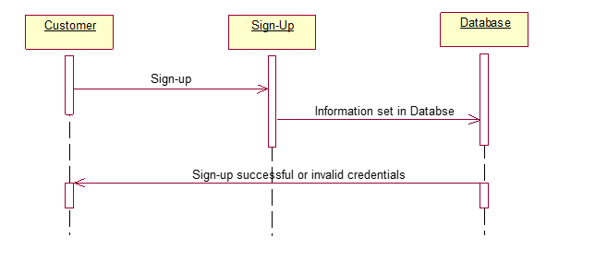

Customer: Sign-In

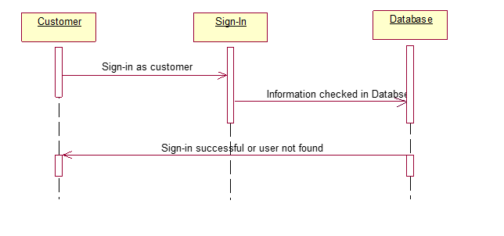

Customer:Sign-Out

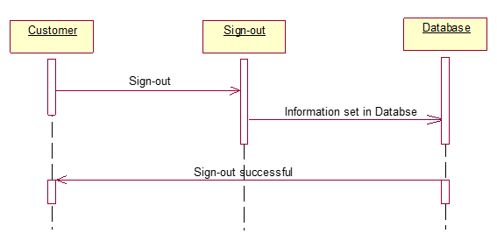

Customer: Request a Worker



Customer: Request a Booking



Worker: Accept Booking



Worker: Sign-In

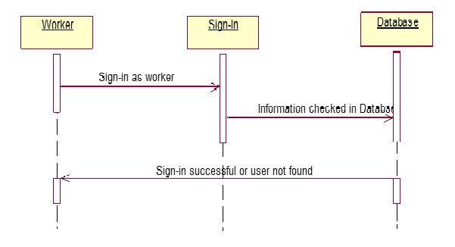

Worker: Sign-Up

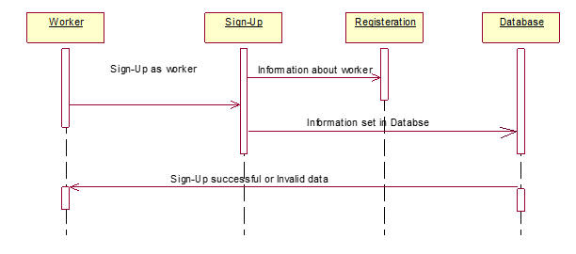

Worker:Sign-Out

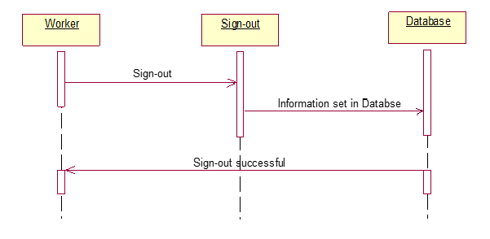

Worker:Accept Request



Collaboration Diagrams

Customer:Sign-Up



Customer:Sing-In



Customer:Sign-Out



Customer:Request a worker



Customer: Request a booking



Worker:Sign-In



Worker:Sign-Out



Worker:Sign-Up



Worker:Accept request



Worker:Accept Booking

